

**School of Computer Sciences**

**Universiti Sains Malaysia**

**CAT 300 -**  **GROUP INNOVATION PROJECT**

**PROJECT INTERIM REPORT**

Mobile Application using Sensors to Detect Humidity and Temperature

**DEADLINE: 31 OCT 2018**

**Group Members**

|  |  |  |
| --- | --- | --- |
| **Name** | **Matric No.** | **Email** |
| Cheryll Anne Augustine | 132889 | Cheryll7@student.usm.my |
| Bhavani Devi A/P Ravichandran | 132883 | bhavni97@student.usm.my |
| Iman Haris Bin Hadi | 135424 | imanharis.hadi@student.usm.my |

**Academic Session**

**2018/2019**

**Declaration Page**

“We declare that all this submitted work is entirely our own except for those sources which we have referenced, and that it has not been previously submitted for assessment in any course”.

_____________________________

(Cheryll Anne Augustine)

_____________________________

(Bhavani Devi A/P Ravichandran)

_____________________________

(Iman Haris Bin Hadi)

**Acknowledgement**

We would like to express our deepest appreciation to Dr. Hadeel Saleh Haj Aliwi, our project supervisor whose contribution and stimulating suggestions and encouragement, helped us to organize our project well. Also not forgetting our coordinator, Mr. Mohd Azam Osman, for providing us the greatest assistance and guidance in order to implement our report. We would also like to extend our gratitude to the staffs and technicians of the laboratory of School of Computer Science, Universiti Sains Malaysia for their kind help in offering and allocating the resources needed for us to come up with the system. Finally, we would like to greatly thank our parents and family for their constant support and encouragement throughout our studies and time allocated for this project.

**Abstract**

With the constant advancement in technology over the years, it has contributed greatly to the agricultural industry. Agricultural biotechnology has made it possible for farmers to grow crops quickly and safely. The expansion of agricultural technology has ease farmers’s work in many ways such as transportation, planting, cropping and storage.

Although the advancement is vast, one of the important aspects of it has not been focused is in the maintenance and storage of the crops. Cooling facilities has been provided but temperature and humidity may also vary from time to time and farmers are not aware or alerted on it, this may cause the to lose their model and profits.

Our project main focus is on the storage and monitoring of food stock and crops. We used BeagleBone Black microcomputer with MWICOM board module coupled with sensors to detect the changes in temperature and humidity. In addition we also used a cloud platform ThingSpeak to mine and analyze the data which will be then sent to a mobile application which farmers can use to monitor their storage facility from anywhere at any time.

**Table of Contents**

**1.0 Introduction** **7**

1.1 Background 7

1.2 Problem Statement 7

1.3 Proposed Solution 7

1.4 Project Objectives 8

1.5 Motivation 8

1.6 Benefit or Impact of The Proposed Solution 8

1.7 Uniqueness of Proposed Solution 8

1.8 Contribution 9

1.9 Organization of the report 10

**2.0 Background Study & Related Work** **10**

2.1 Existing System 10

2.2 Features Comparison of the existing System 10

2.3 Existing Technique/Algorithm/Method 11

**3.0 System Requirements and Analysis** **11**

3.1 Status of project development 11

3.2 Scope of the proposed solution 12

3.3 System Capabilities & Limitations 12

3.4 Project Management 13

3.4.1 Work Breakdown Structure 13

3.4.2 Gantt Chart 13

3.4.3 SWOT Analysis 13

3.5 Development Methodology 14

3.6 Analysis of Proposed Solution/Project 15

3.6.1 Identify users’ requirements 15

3.6.2 Gathering Requirements Method 15

3.7 UML diagram 16

3.7.1 Use Case Diagram 16

3.7.1.1 Use Case Description 17

3.7.2 Activity Diagram 23

3.8 Technology Deployed 23

3.8.1 Hardware Specification 23

3.8.2 Software Specification 24

3.8.3 Programming Languages and Tools Used 24

3.8.4 Chosen Algorithm 24

**4****.0 Reference:** **25**

**Index of Tables & Figures**

**Table Index**

Table 1 : Contribution Table. 10

Table 2: System Capability. 13

Table 3: System Limitation. 13

Table 4: SWOT Analysis Table. 15

Table 5: Requirement Gathering Suma\mary. 17

Table 6: Use Case Diagram Summary. 17

Table 7: Create Account Use Case Description. 18

Table 8: Collect Data Use Case Description. 20

Table 9: Interpret Data Use Case Description. 21

Table 10: Store Information Use Case Description. 22

Table 11: Provide Humidity and Temperature Information Use Case. 23

Table 12: Hardware Specification Summary. 24

Table 13: Software Specification Summary. 25

Table 14: Programming Languages and Tools Summary. 25

**Figure Index**

Figure 1: WBS Figure. 14

Figure 2: Gantt Chart. 14

Figure 3: Next Steps Iteration tracked by Gantt Chart. 16

Figure 4: Use Case Diagram. 17

Figure 5: Create Account Activity Diagram & Sequence Diagram. 19

Figure 6: Collect Data Activity Diagram & Sequence Diagram. 20

Figure 7: Interpret Data Activity Diagram & Sequence Diagram. 21

Figure 8: Store Information Activity Diagram & Sequence Diagram. 22

Figure 9: Provide Humidity and Temperature Information Activity Diagram & Sequence Diagram. 23

Figure 10: Activity Diagram. 24

# 

# **1.0 Introduction**

## 

## 1.1 Background

The project aims to create a mobile application that can interact with a hardware coupled with sensors that detects humidity and temperature. We aim to create an IoT (Internet of Things) solution that can help solve one of the problems that farmers and food handlers’ face, the monitoring and quality of food stock. The projects is designed by using the MWICOM board and BeagleBone Black along with few humidity and temperature sensors which is then connected to a cloud platform that will be used by the mobile application to interact.

## 1.2 Problem Statement

Malaysia is famous for agriculture but the agricultural field here is still not very much developed, where it does not provide farmers with the ease of keeping an eye on their food stock. Some large agricultural organizations would own these technologies but at a much higher price that is unaffordable for the smaller agricultural community. This possesses a serious threat to them especially with the abrupt weather changes occurring which they are not alerted of, the hard work of these farmers go to waste as the food stocks degrade in quality and gets rotten faster. This is either due to the excessive high temperature or high humidity. These are the basic conditions where food should not be kept, as most of the food products are required to be stored in dry places and in cold or optimal temperature. Therefore a sudden surge in temperature or humidity would affect the food products and farmers would suffer big losses.

## 1.3 Proposed Solution

An existing solution that is available to the Malaysian market is developed by a company called Xperanti IoT (M) Sdn Bhd which provides many solution services which includes the agricultural sector of food handling [1]. However, after further research, we found that there is a lack of competition in the local market. Therefore, by offering our cheaper solution as an alternative, it might increase the quality of agricultural based IoT solution as well as improve the cost-benefit for farmers.

## 1.4 Project Objectives

Our primary objective that we would like to achieve in this project are:

* To provide farm-owners, high technological access with low-cost expenses
* To increase their yield.
* To upgrade the technological standard of the agricultural community.

## 

## 1.5 Motivation

Our main motivation in the process of making this project is to further enhance our skills and knowledge as well as creating the initiative to propel more IoT projects. Another motivation of ours is to make use of our knowledge on IoT hardware and software such as the BeagleBone Black, cloud platforms and mobile application development. Part of our wish is also to contribute to IoT and the agricultural community and economy.

## 1.6 Benefit or Impact of The Proposed Solution

Our unique solution is to use the BeagleBone Black microcontroller and connect it to the MWICOM board module. This enables the device to be able to have GPS location tracked as well as wireless networks module that can be used by the sensors to connect to the internet. We also included humidity and temperature sensors that will be soldered to a mini board. This enables the device to have a small-form factor and easy to maintain. In addition, we developed an android app that can be used to monitor the condition of food stock so users can check them whenever it is convenient. We programmed the device to compute and send data to cloud platform Thingspeak, which will then communicate with the android app through RESTful API to visualize the data in a meaningful way to users [2]. Lastly, this project will be built on hardware using low-cost and durable hardware that has a small form factor.

## 1.7 Uniqueness of Proposed Solution

One of the uniqueness of our proposed solution is the inclusion of a mobile application that can be used by the user to monitor the condition of food stock in real time. It also creates an opportunity to create competition to upstart IoT (Internet of Things) development more.

## 1.8 Contribution

List of tasks/works for each individual:

|  |  |
| --- | --- |
| Group Members | Tasks |
| Iman Haris Hadi  (Programming and Designing Mobile application) | * Responsible over the Programming of the Mobile Application associated with this project, including the design aspects of the application. * Acts as a general leader of the project, oversees and integrates all four modules into one. * Responsible in the design phase as well as analysis of system requirements of the documentation. |
| Cheryll Anne  (Programming database and maintaining cloud platform) | * Maintain the cloud platform, Thingspeak to which the Android application and the Black BeagleBone Board are able to communicate and interpret data with. * Develops a functional database designed to collect information and data to be stored in Thingspeak channel to be used by the application. |
| Bhavani Devi  (Sensor and microcontroller programming) | * Responsible in testing, integrating and building the entire, including its BeagleBone Black microcontrollers, the mainboard MWICOM board module as well as all the sensors. * Programming of the BeagleBone Black, and integrating it to the Thingspeak platform. * Ensures connection between the microcontrollers, database and Android application is established and maintains the reliability of that connection. |

##### Table 1 : Contribution Table.

## 

## 1.9 Organization of the report

This report comprises of 4 parts. The next section, chapter 2 examines on background study and the related work of this topic. It is necessary to survey and study existing applications such as mobile application using sensors to detect temperature and humidity in order to improve and market this new system. The existing framework of the application will be summarized and their technique, algorithms, quality, shortcoming and opportunities will be examined. The third chapter will discuss the framework analysis and requirement analysis. Project management, various kind of possibility evaluation and improvement strategy will be additionally discussed about. Besides that, this report examines new framework with suitable diagrams which is the UML diagram that includes, activity diagram and sequence diagram. This chapter also discusses the types and specifications of hardware and software that will be used. The fourth chapter has been completed additionally. This chapter deeply discusses the design of the system which includes the architecture, system components that describes the components and functions of each subsystem, the database design and class diagram of the system. Last but not least, interface design and an interface prototype is proposed in this chapter and it also extends to the discussion of the input and output design used for this application.

# 2.0 Background Study & Related Work

## 2.1 Existing System

There is an existing solution that is available to the Malaysian market that provides many solution services which includes the agricultural sector of food handling [1]. As we conducted researches, we found that there is a lack of competition in the local market and it is not affordable to the local farmers with a smaller agricultural scale. Therefore, by offering our cheaper and complete solution as an alternative, it might increase the quality of agricultural based IoT solution as well as improve the cost-benefit for farmers both involved either in big scale or small scale farming.

## 2.2 Features Comparison of the existing System

Based on our research on different applications, we have realised that there are very few existing applications that collect, interpret and display information on the food stock to the owners or farmers at real time and cost efficient. By sending data to the cloud and displaying data in a simple and understandable way in the application makes it easier for the owners and users to keep track of the food without requiring special knowledge. This will be more user-friendly and helpful to the farmers in rural areas. Owners also would not be required to make constant trips to the stock warehouse or store as they will be updated on the stock conditions from time to time and will be alerted immediately in case of an abnormal environment. As we use low-cost hardware of pleasing quality, we would be able to lower the price compared to the existing system.

## 2.3 Existing Technique/Algorithm/Method

There are existing methods available in detecting the temperature and humidity in the agricultural field. Our project mainly focuses on the broad use of it in the field by making it available to farmers of all scales. Based on the input from the sensors into the system, it will interpret and calculate the obtained data and displaying it in the form of useful information for the users through the application. Internet of Things (IoT) is an idea of remotely connecting and monitoring real world objects through the Internet. This system is highly prefered over the similar kind of systems is because it would be of low-cost, affordable, with timely and accurate information.

# 3.0 System Requirements and Analysis

## 

## 3.1 Status of project development

For our project, our system is made from scratch with the help of the team and our supervisor. It is a new idea we created with the help of our supervisor’s advice. To track the status of our project, other than our gantt chart, we also kept a checklist as below:

* Requirement Gathering (Completed).
* Design (In Progress).
* Testing (Not Ready).
* Implementation (Not Ready).

Currently, we are in the designing phase of where we are discussing functions that will match user needs.

## 

## 

## 3.2 Scope of the proposed solution

Currently, the scopes achievable for our proposed system are as below:

* Mobile application able to obtain data from ThingSpeak Cloud platform.
* Mobile application able to view chart feed from data obtained from ThingSpeak.
* User account able to be verified and lead to the correct ThingSpeak channel for graph viewing.

## 3.3 System Capabilities & Limitations

This section will identify the required system capabilities and limitations at high level. These are capabilities and limitation listed:

|  |  |
| --- | --- |
| System Capability | |
| Provide the capability for customers to view real-time data | Customer has the access to view sensors 24/7 in their mobile application at anywhere and anytime. |
| Provide the capability to view more than one channel | Allows customer to access more than one sensor channel. |
| Provide the capability to store customer details | Customer details such as name, email and password are stored in the cloud. |

##### Table 2: System Capability.

|  |  |
| --- | --- |
| System Limitation | |
| System must be connected to the Internet | The database is in the cloud. The mobile application should be connected to the cloud so that customers can view the sensor data. |
| Sensors are placed in a fixed place | The mobility of the sensors are fixed. |

##### Table 3: System Limitation.

## 

## 3.4 Project Management

### 3.4.1 Work Breakdown Structure

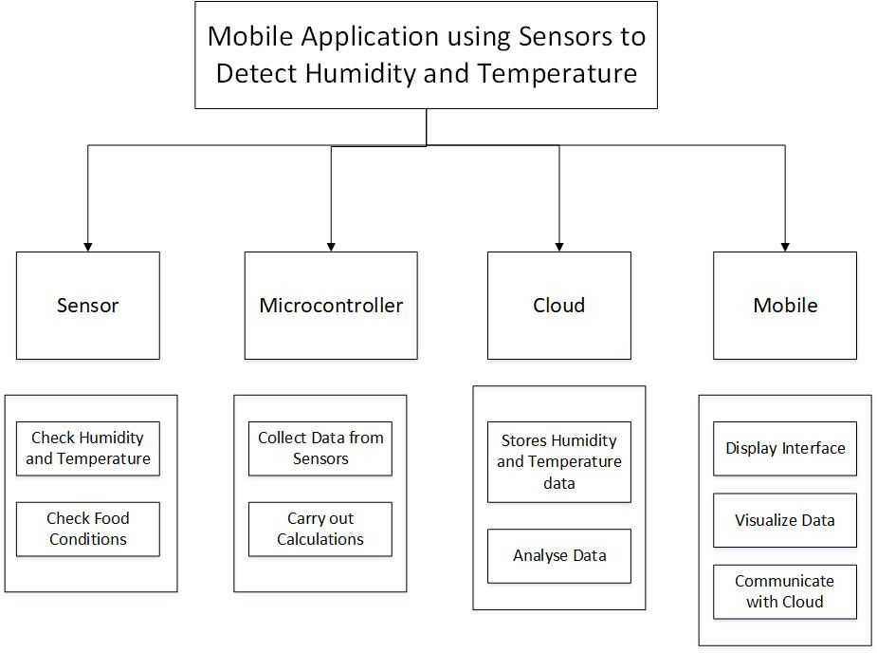

###### Figure 1: WBS Figure.

### 3.4.2 Gantt Chart

###### Figure 2: Gantt Chart.

### 3.4.3 SWOT Analysis

|  |  |
| --- | --- |
| Strengths | Weaknesses |
| * Low cost tools to develop mobile application. * APIs are readily available for development * Sensor cost are low. * Able to view sensor data anywhere. * Storing data is convenient using cloud platform. | * Mobile application compatibility. * High cost of microcomputer. * Have to use external database cloud platform to store data. |
| Opportunities | Threats |
| * Growth of the Internet of Things (IoT) industry. * Advancement and demand of new agricultural technologies. * Low competition in Malaysia market. | * Security vulnerability. * Volatile industry because of newer microcomputers models released. |

##### Table 4: SWOT Analysis Table.

## 3.5 Development Methodology

In our project we have implemented agile methodology. We chose this methodology as it satisfies the customers as it is flexible. Moreover, this implementation is evolutionary as a prototype gets better upon every cycle. Thus, productivity increases. Furthermore, the customers can provide feedback as the project evolves without holding back the project. Therefore, agile method is more suitable for this project.

**Iteration 1**

i. Project planning

* Develop sensors and build schedule and then plan the work- 1 day.

ii. Analysis tasks

* Meet the lecturer - ½ day.
* Define requirements information and data elements(discuss among groupmates)- 1 day.
* Modal user activities- ½ day.

iii. Design tasks

* Design screen layouts and cross links required in the project - 1 day.
* Identify program classes and methods- 1 day.

iv. Build tasks

* Connect to Firebase database - 1 day.
* Write program code- 5 days.
* Build test data- 4 days.
* Set up user-friendly environment - 1 day.
* Perform acceptance tests with users- 2 days.
* Release acceptance version- ½ day.
* Perform team introspection- ½ day.

**Iteration 2**

###### Figure 3: Next Steps Iteration tracked by Gantt Chart.

## 

## 3.6 Analysis of Proposed Solution/Project

### 3.6.1 Identify users’ requirements

To achieve our project, requirements gathering techniques are used to collect both functional and non-functional requirements from our stakeholders. Among the gathering techniques have been used in this project includes observation, review documents and collecting user requirements and reviews. Based on our observation one of the most requested feature of a sensor monitoring application is easy user interface. Most sensor monitoring applications reviewed in Google Play store and Apple store are very complex.

### 

### 3.6.2 Gathering Requirements Method

We managed to collect some data on how to achieve user requirements by such followings:

|  |  |
| --- | --- |
| Methods | Explanation |
| Internet search | We managed to obtain plenty of information from the internet. There are information on how to reach users requirements such as good user interface of mobile application, display real-time data and many more. |
| App store search | There are applications such as My AcuRite in the market that is something alike our project but with certain limitations. We learnt the basic criteria needed for this project. |
| Interview | We conducted interview with some university students about our project. As results, we learnt that most prefer simple and straightforward user interface and many more. |

##### Table 5: Requirement Gathering Suma\mary.

## 

## 3.7 UML diagram

### 3.7.1 Use Case Diagram

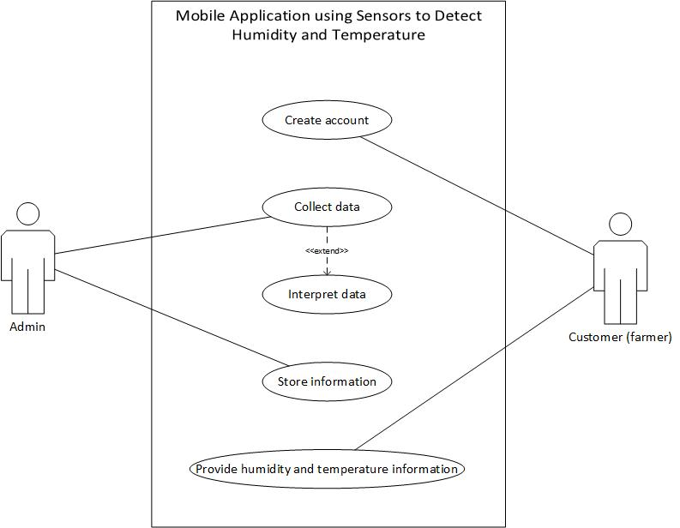

###### Figure 4: Use Case Diagram.

|  |  |
| --- | --- |
| Use Case Name | Brief Description |
| Create account | System provides capability for user to create account for customers. |
| Collect data | System accumulates humidity and temperature data from sensor. |
| Interpret data | System interprets the data collected from the sensors |
| Store Information | System stores sensor data in the cloud |
| Provide humidity and temperature information | System outputs the information |

##### Table 6: Use Case Diagram Summary.

#### 3.7.1.1 Use Case Description

|  |  |  |
| --- | --- | --- |
| Use Case | Create Account | |
| Scenario | Verify customer account if exist or not | |
| Triggering Event | Customer requests account. | |
| Brief Description | Customer details such as name, email and password are requested and stored in cloud database storage | |
| Actors Involved | Customer | |
| Related Use Cases | Create account | |
| Stakeholder Involved | Customer, cloud service provider, system | |
| Precondition | Connected to cloud database.  Customer enable to create account.  Predefined database. | |
| Postcondition | Stores details of customers. | |
| Flow of Activity | Actor | System |
|  | * Customer creates an account. * Customer enters their details. | * System stores customer details. * System verifies the account. |
| Exception Condition | * Internet connection not available. * Cloud database corruption. | |

##### Table 7: Create Account Use Case Description.

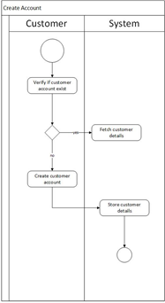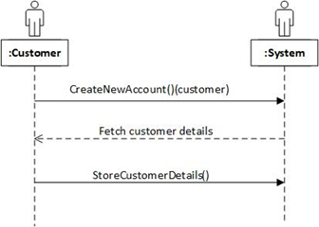

###### Figure 5: Create Account Activity Diagram & Sequence Diagram.

|  |  |  |
| --- | --- | --- |
| Use Case | Collect data. | |
| Scenario | Receives humidity and temperature data from the sensors. | |
| Triggering Event | Every second the sensors collect data. | |
| Brief Description | Sensor data which are raw are sent to carry out calculations. | |
| Actors Involved | Sensors. | |
| Related Use Cases | Interpret data. | |
| Stakeholder Involved | Cloud service provider and system administrator. | |
| Precondition | * Connected to cloud. * Received information. * Predefined database. | |
| Postcondition | * Stores sensors data/ | |
| Flow of Activity | Actor | System |
|  | * Provides humidity and temperature data | * Data is sent from sensor to microcontroller |
| Exception Condition | * Internet connection not available. * Cloud database corruption. | |

##### Table 8: Collect Data Use Case Description.

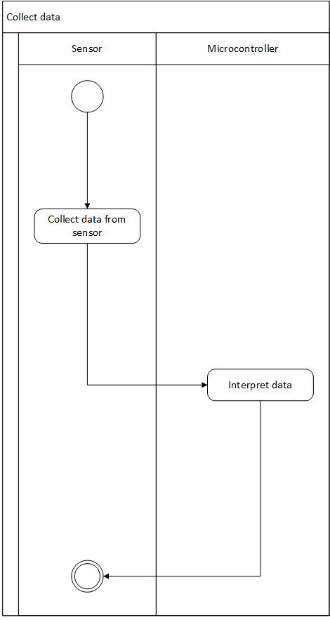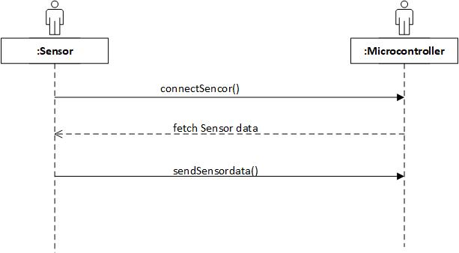

###### Figure 6: Collect Data Activity Diagram & Sequence Diagram.

|  |  |  |
| --- | --- | --- |
| Use Case | Interpret data. | |
| Scenario | The system does calculations to get humidity and temperature readings. | |
| Triggering Event | Every input from sensors are calculated. | |
| Brief Description | Raw data from the sensor are calculated such as Humidity (RH) and Temperature (℃). | |
| Actors Involved | Microcontroller and Sensor. | |
| Related Use Cases | Collect data. | |
| Stakeholder Involved | System administrator. | |
| Precondition | * Received data. * Predefined formula. * Connected to sensors. | |
| Postcondition | * Connected to cloud | |
| Flow of Activity: | Actor | System |
|  | * Provides humidity and temperature | * Microcontroller calculates the data |
| Exception Condition | * Faulty in sensors. * Unavailable connectivity to cloud. | |

##### Table 9: Interpret Data Use Case Description.

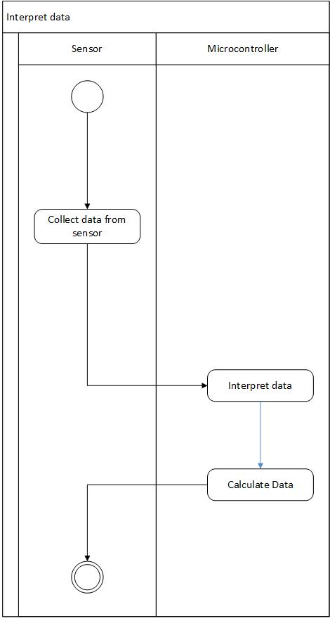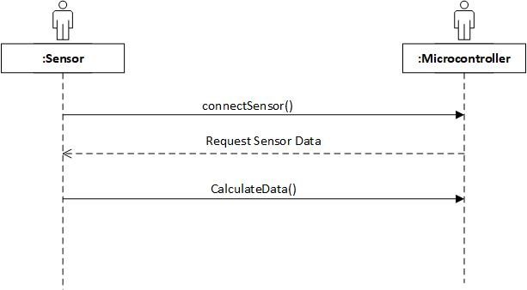

###### Figure 7: Interpret Data Activity Diagram & Sequence Diagram.

|  |  |  |
| --- | --- | --- |
| Use Case | Store information | |
| Scenario | Receives customer account details and sensor informations. | |
| Triggering Event | When customer inputs their account details and sensor informations. | |
| Brief Description | Customer details such as name, email, and password and sensor information are stored. | |
| Actors Involved | Customer. | |
| Related Use Cases | Create account and Collect data. | |
| Stakeholder Involved | Cloud service provider, Customer and Sensors. | |
| Precondition | * Connected to cloud. * Received information. * Predefined database. | |
| Postcondition | * Stores customer details. * Stores sensor information. | |
| Flow of Activity | Actor | System |
|  | * Provide customer details * Provide sensor information | * System stores customer and sensor information in cloud storage |
| Exception Condition | * Internet connection not available. * Cloud database corruption. | |

##### Table 10: Store Information Use Case Description.

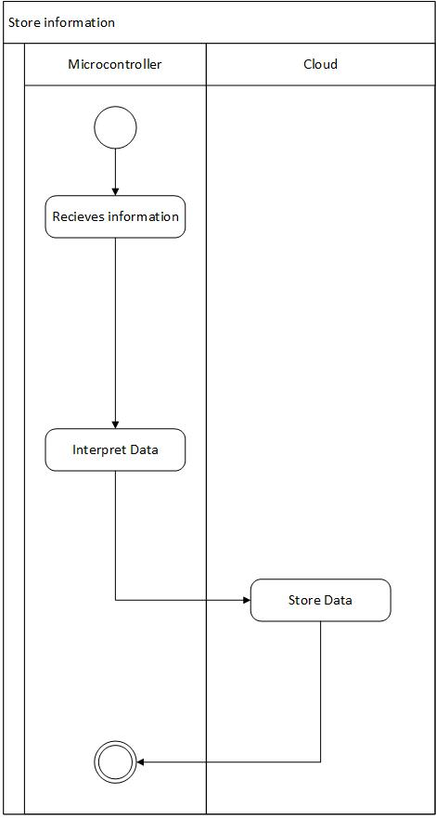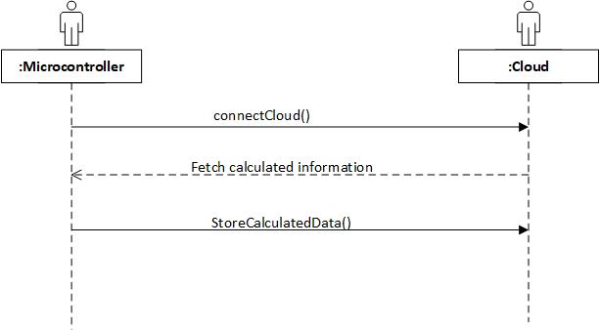

###### Figure 8: Store Information Activity Diagram & Sequence Diagram.

|  |  |  |
| --- | --- | --- |
| Use Case | Provide humidity and temperature information. | |
| Scenario | Provide humidity and temperature information to be displayed to the customer. | |
| Triggering Event | Once customer selects to view information | |
| Brief Description | System collects sensor information from the cloud and displays them to customer. | |
| Actors Involved | Customer and mobile application. | |
| Related Use Cases | Store information. | |
| Stakeholder Involved | Customer, cloud service provider. | |
| Precondition | * Customer logged in. * Customer selects the sensor channel | |
| Postcondition | * Display sensor details. | |
| Flow of Activity | Actor | System |
|  | * Customer logs in. * Customer selects sensor channel. | * System collects sensor data * Display sensor information. |
| Exception Condition | * Internet connection not available. * Customer not logged in. | |

##### Table 11: Provide Humidity and Temperature Information Use Case.

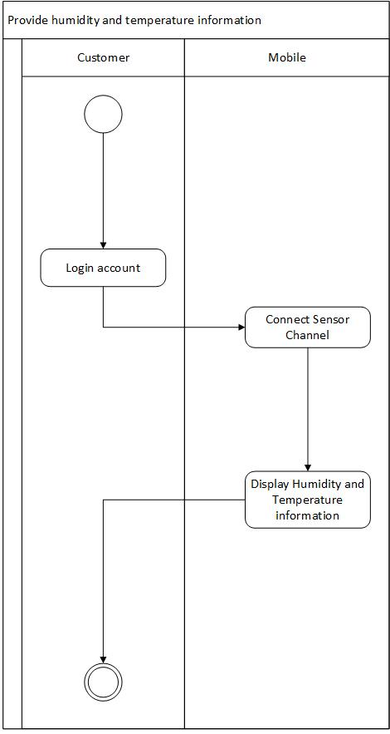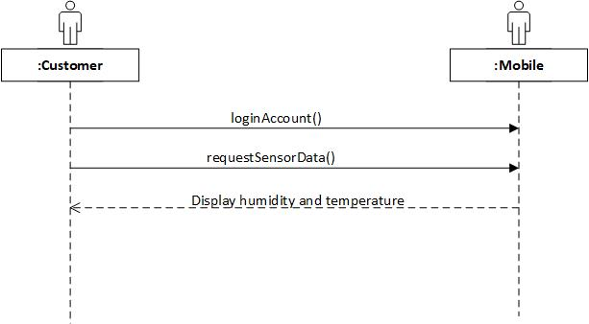

###### Figure 9: Provide Humidity and Temperature Information Activity Diagram & Sequence Diagram.

### 3.7.2 Activity Diagram

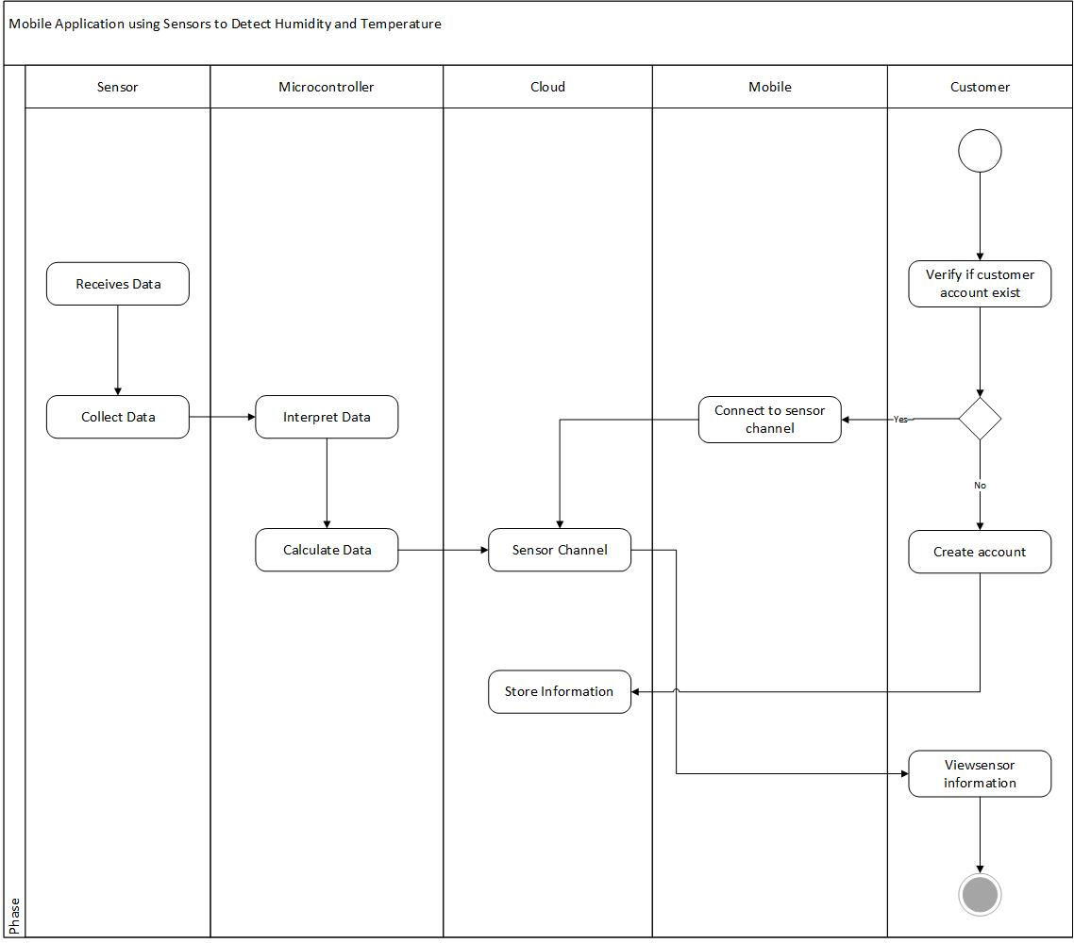

###### Figure 10: Activity Diagram.

## 3.8 Technology Deployed

### 3.8.1 Hardware Specification

The followings are the hardware used for this project.

|  |  |
| --- | --- |
| **Hardware** | **Specification** |
| Temperature sensor | TMP36. |
| Humidity Sensor | HS 1101. |
| Sensor development board | Black BeagleBone MWICOM board module. |
| Mobile | Android 7.0 and above. |

##### Table 12: Hardware Specification Summary.

### 

### 3.8.2 Software Specification

The followings are the software used for the project.

|  |  |
| --- | --- |
| **Software** | **Specification** |
| Black BeagleBone | Linux operating system |
| Mobile application | Android Studio |
| Connection of sensor to cloud | Thingspeak |
| Database | Firebase |

##### Table 13: Software Specification Summary.

### 3.8.3 Programming Languages and Tools Used

|  |  |
| --- | --- |
| **Tools** | **Programming languages** |
| Black BeagleBone | C++ |
| Mobile application | Java |

##### Table 14: Programming Languages and Tools Summary.

### 3.8.4 Chosen Algorithm

The data directly from the sensor was in Voltage readings. The following algorithm was implemented to convert volt to as respective readings.

|  |  |
| --- | --- |
|  | **Algorithm** |
| **Humidity Sensor** | Vout=Vcc *(0.00474*%RH+0.2354)  for 5 - 99% RH  Typical temperature coefficient : +0.1% RH/°C - From 10 to 60°C |
| **Temperature Sensor** | Temp in °C = [(Vout in mV) - 500] / 10  VS = 2.7 V to 5.5 V, −40°C ≤ TA ≤ +125°C, unless otherwise noted. |

# 

# 

# 4.0 Reference:

Humidity sensor Datasheet

<https://www.parallax.com/sites/default/files/downloads/27920-Humidity-Sensor-Datasheet.pdf>

Temperature sensor Datasheet

<http://ctms.engin.umich.edu/CTMS/Content/Activities/TMP35_36_37.pdf>